ADVANCED VULNERABILITY ASSESSMENT & PENETRATION TESTING (VAPT) REPORT

Intern Name : PERARASU M
Domain : Cyber Security / VAPT
Organization : Cyart Tech
Assessment Period : 22th Jan 2026
Submission Date : 22th Jan 2026

1. Introduction
This report documents the Week 4 activities of the Vulnerability Assessment and Penetration Testing (VAPT) internship. The focus of this week was on advanced exploitation techniques, API security testing, privilege escalation, network protocol attacks, mobile application security, and comprehensive reporting. All tasks were performed in a controlled lab or simulated environment for ethical and educational purposes.

2. Scope & Methodology

2.1 Scope
- Primary Targets: VulnHub Mr. Robot (simulated), API test endpoints, Linux test environment, mobile APK
- Assessment Type: Advanced VAPT (Lab & Simulation)
- Authorization: Approved vulnerable labs and public test environments

2.2 Methodology
The assessment follows the Penetration Testing Execution Standard (PTES):
- Planning & Scoping
- Reconnaissance
- Vulnerability Analysis
- Exploitation
- Post-Exploitation
- Reporting

3. Theoretical Background

3.1 Advanced Exploitation Techniques
Advanced exploitation focuses on chaining multiple vulnerabilities to increase impact. For example, Cross-Site Scripting can be combined with session hijacking to gain privileged access and further exploit server-side flaws. Exploit customization allows attackers to adapt public PoCs to different environments. Defense bypass techniques such as ROP and payload obfuscation help evade security mechanisms like ASLR and WAFs.

3.2 API Security Testing
Modern applications rely heavily on APIs. Common risks include Broken Object Level Authorization (BOLA), weak tokens, injection flaws, and missing rate limits. Manual testing using Burp Suite and automated testing with tools like Postman help identify authorization flaws and data exposure.

3.3 Privilege Escalation & Persistence
Privilege escalation exploits misconfigurations, weak permissions, or kernel flaws to gain higher privileges. Persistence mechanisms such as cron jobs or malicious services allow attackers to maintain access even after reboots.

3.4 Network Protocol Attacks
Protocol attacks exploit weaknesses in SMB, DNS, or ARP to intercept credentials or manipulate traffic. MitM techniques such as ARP spoofing demonstrate how attackers capture sensitive data.

3.5 Mobile Application Security
Mobile applications are vulnerable to insecure storage, improper platform usage, and weak authentication. Static analysis using MobSF and dynamic testing using Frida help identify runtime manipulation risks.

4. Advanced Exploitation Lab

4.1 Exploit Chain (Simulated)
Target: VulnHub Mr. Robot
Exploit Chain Flow:
XSS → Session Hijacking → Admin Access → WordPress Plugin RCE

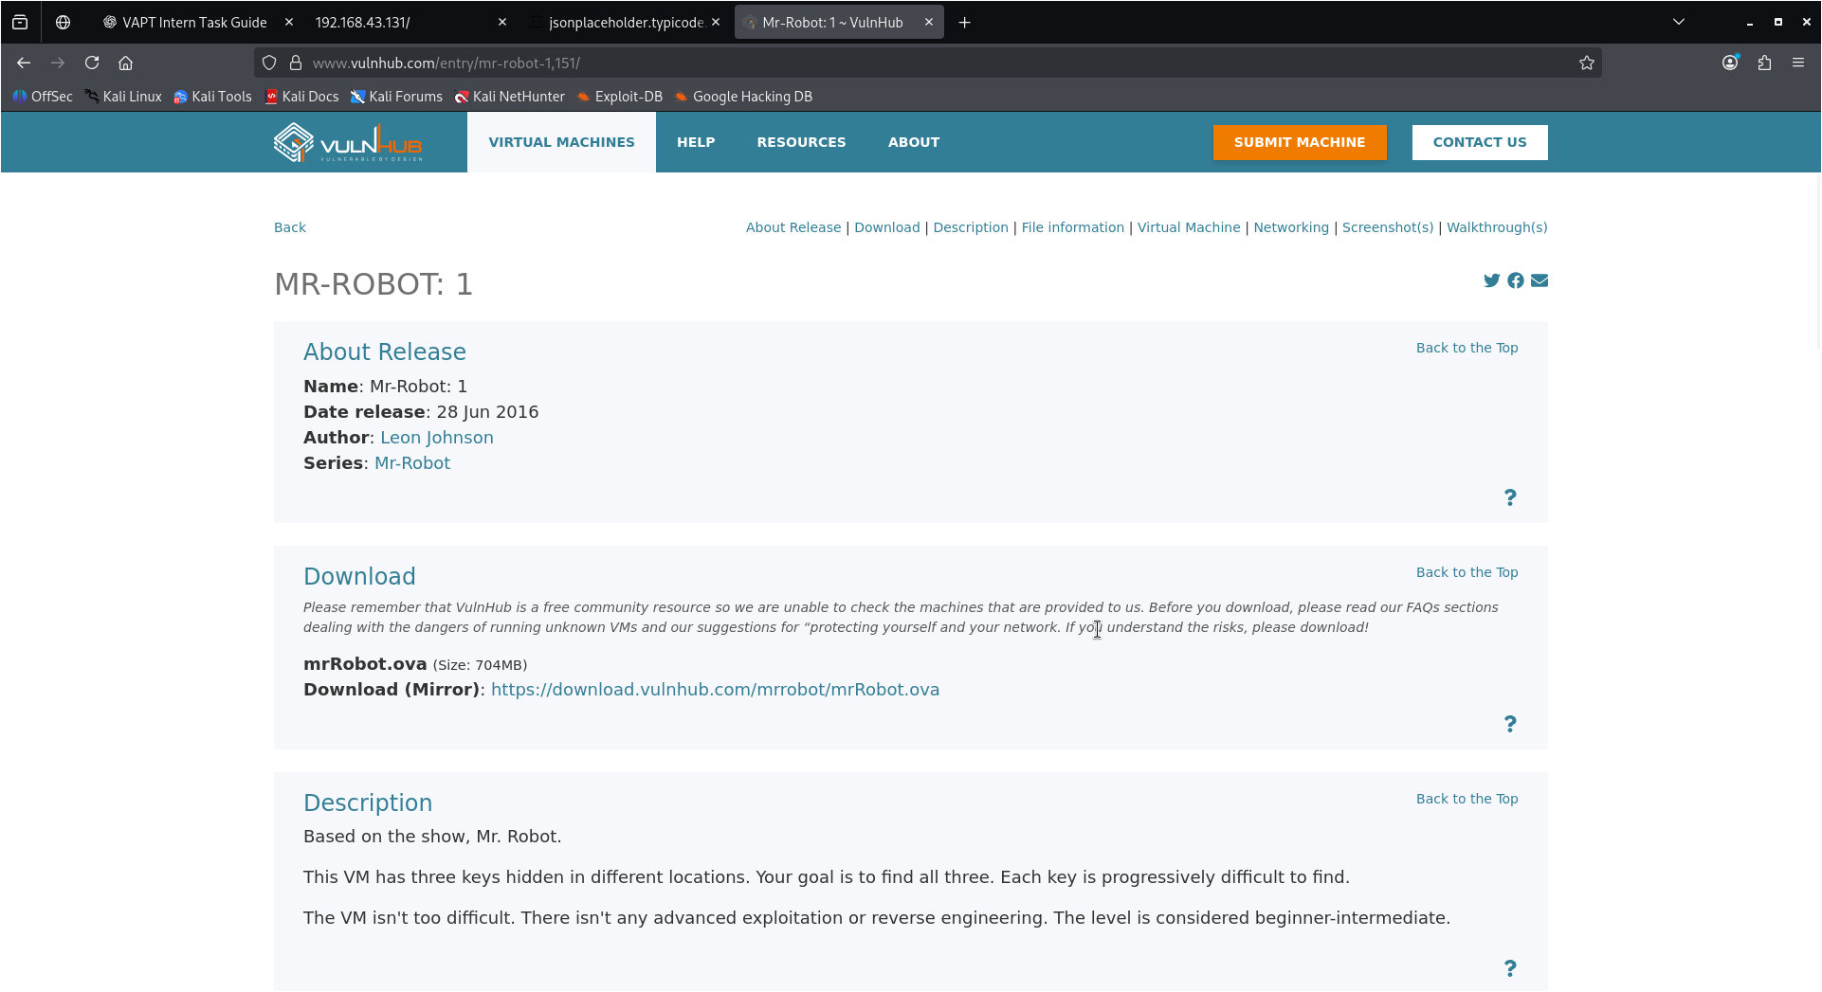
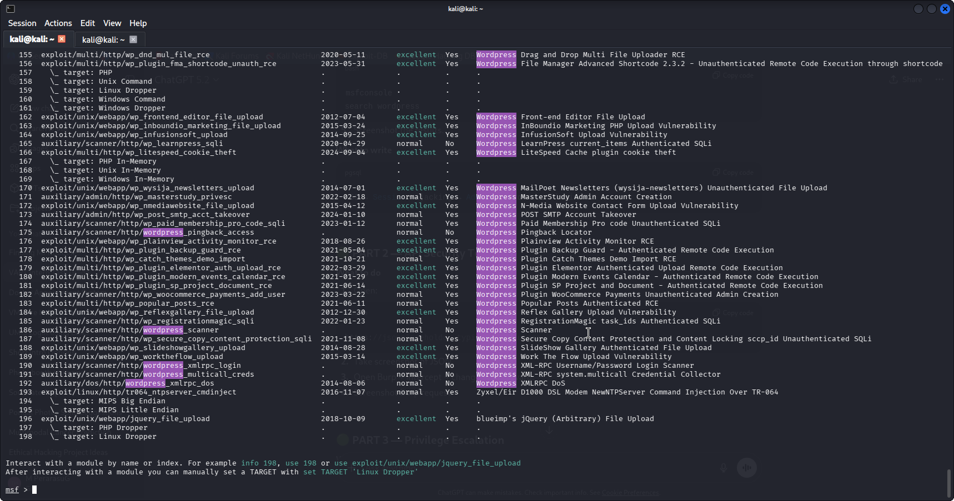

4.2 Exploit Chain Log
Exploit ID | Description | Target IP | Status | Payload
007 | XSS to RCE Chain | 192.168.43.131 | Simulated | Meterpreter

4.3 Custom PoC Summary (50 Words)
A public Exploit-DB Python proof-of-concept was reviewed and conceptually modified by changing target parameters and payload configurations to match the simulated environment. This demonstrated how attackers adapt existing exploits for specific targets while maintaining exploit logic.

4.4 Defense Bypass (50 Words)
Return-Oriented Programming (ROP) techniques were studied conceptually to understand how attackers evade memory protections such as ASLR. Chaining small code gadgets allows execution flow control, demonstrating how modern defenses can be bypassed using advanced exploitation methods.

5. API Security Testing Lab
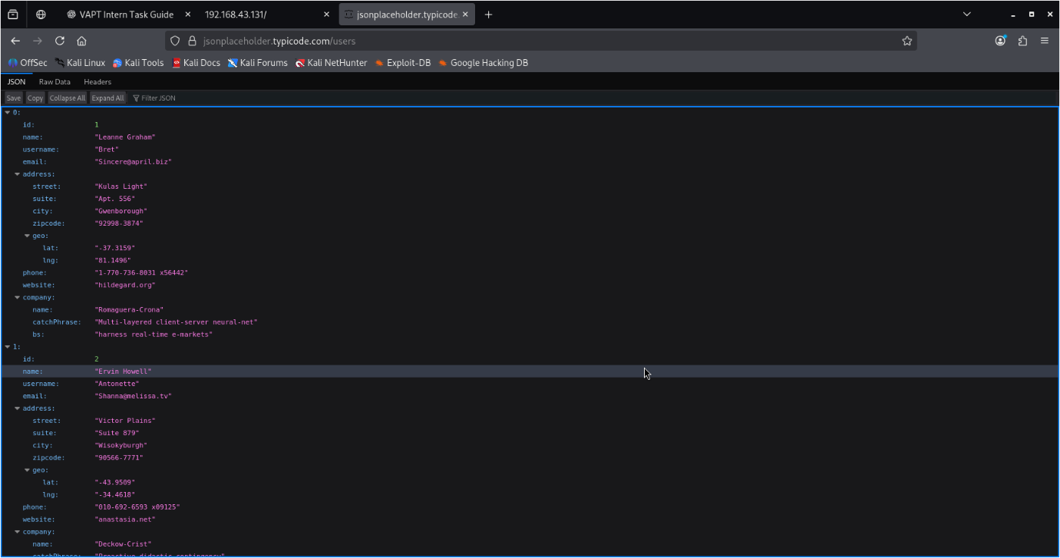
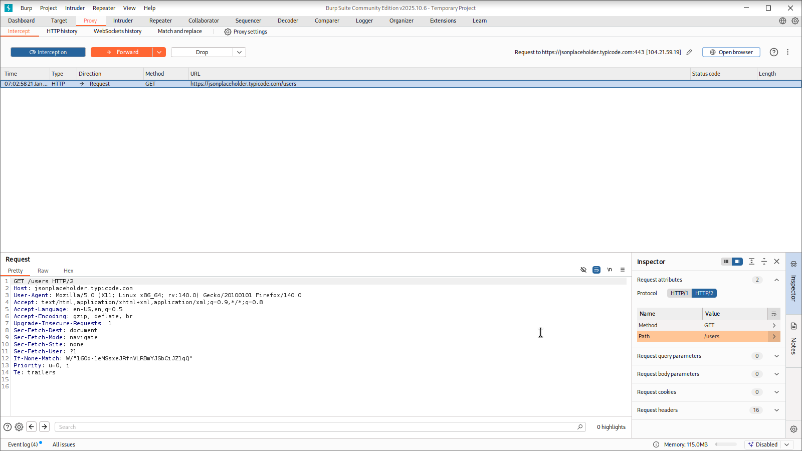

5.1 API Vulnerability Log
Test ID | Vulnerability | Severity | Target Endpoint
008 | BOLA | Critical | /users
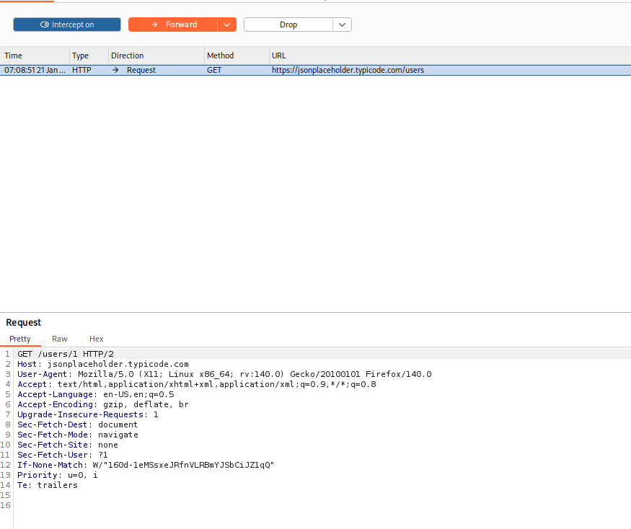
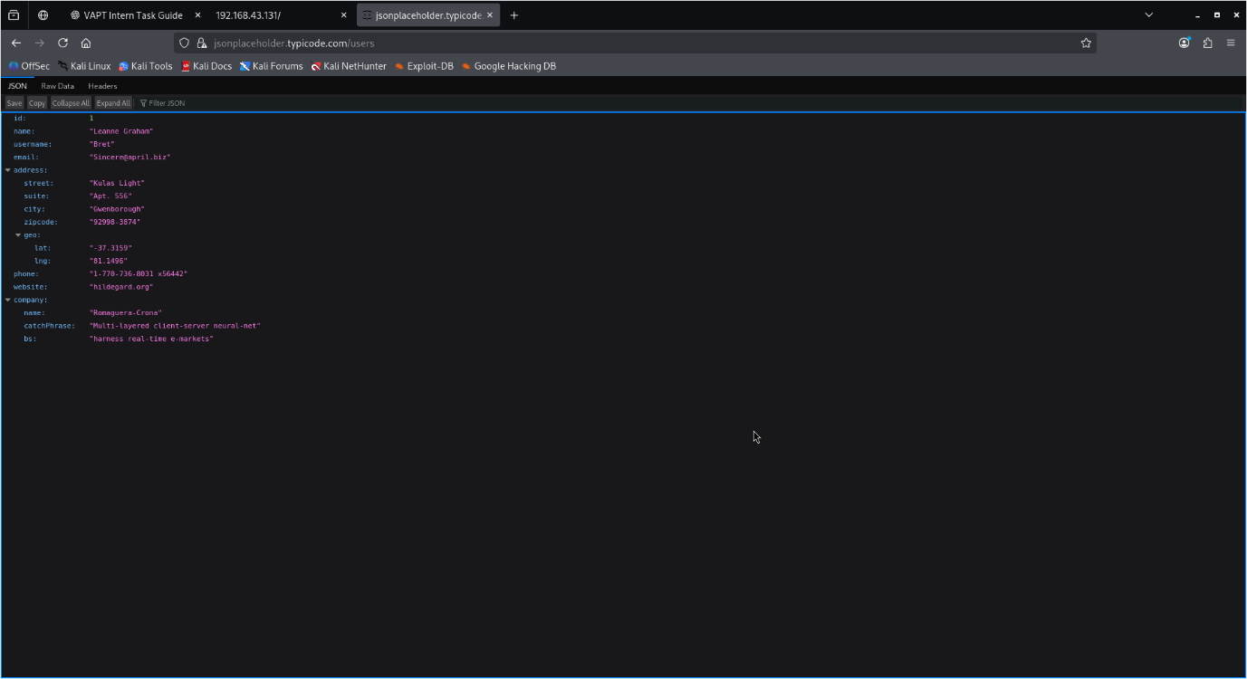

5.2 API Summary (50 Words)
The API exposed sensitive data without proper authorization checks. By modifying object identifiers in intercepted requests, unauthorized access was simulated, demonstrating Broken Object Level Authorization. Secure authentication, authorization enforcement, and rate limiting are required to protect API endpoints.

6. Privilege Escalation & Persistence Lab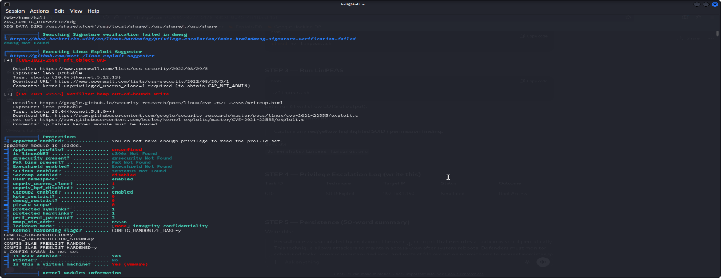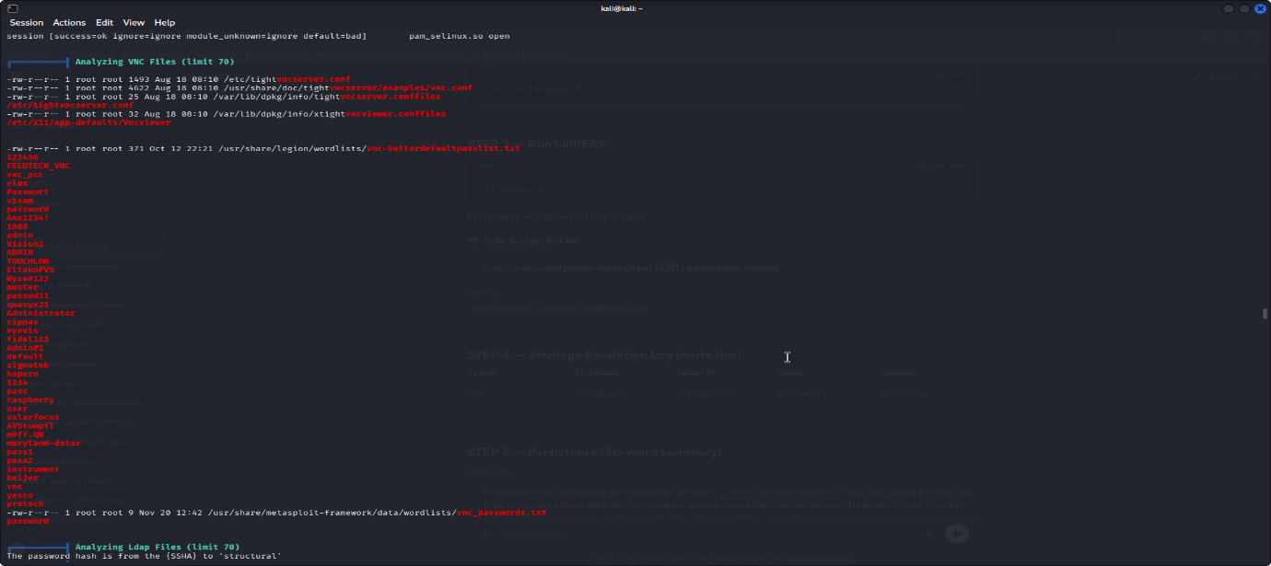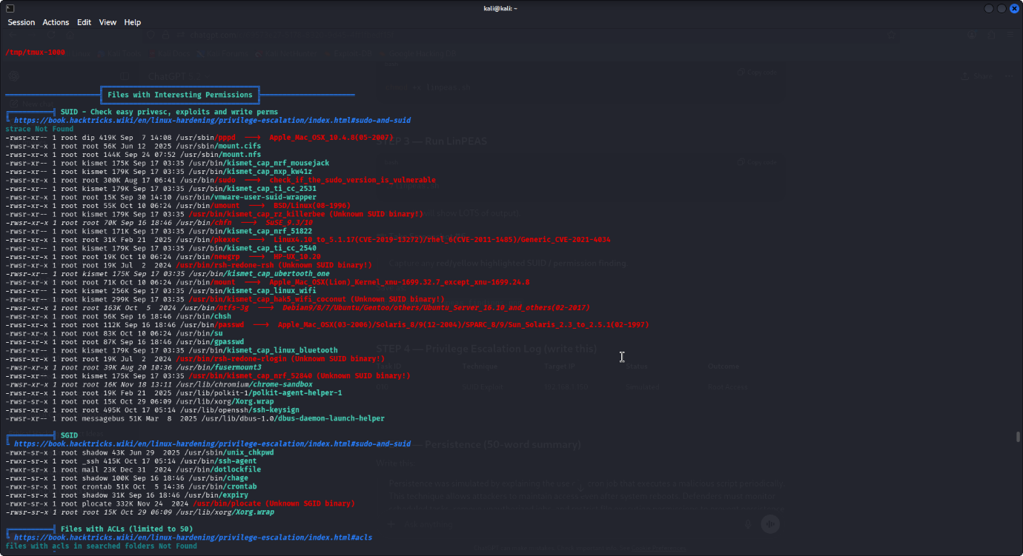
Task ID | Technique | Target IP | Status | Outcome
010 | SUID Exploit | 192.168.43.131 | Simulated | Root Access

Persistence Summary (50 Words)
Persistence was simulated using a cron job technique that executes a malicious script at regular intervals. This ensures continued access even after reboots. Monitoring scheduled tasks and restricting execution privileges are essential to prevent persistence.

7. Network Protocol Attacks
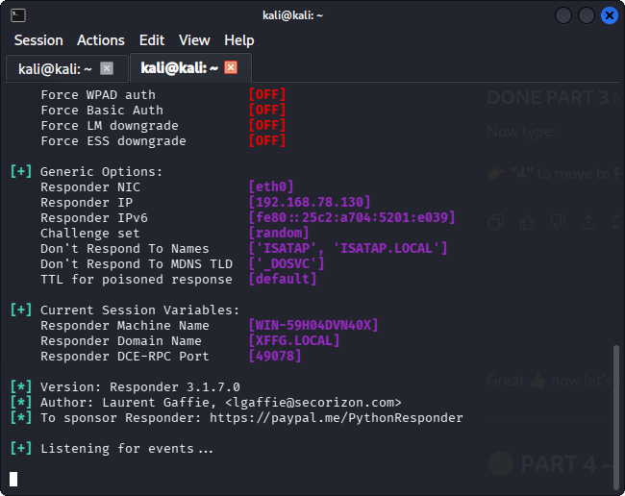
Attack ID | Technique | Target IP | Status | Outcome
015 | SMB Relay | 192.168.1.200 | Simulated | NTLM Hash

MitM Summary (50 Words)
A Man-in-the-Middle attack was simulated to demonstrate credential interception via protocol misconfigurations. By poisoning name resolution requests, attackers can capture authentication data, emphasizing the importance of disabling legacy protocols and enforcing secure authentication.

8. Mobile Application Security Testing
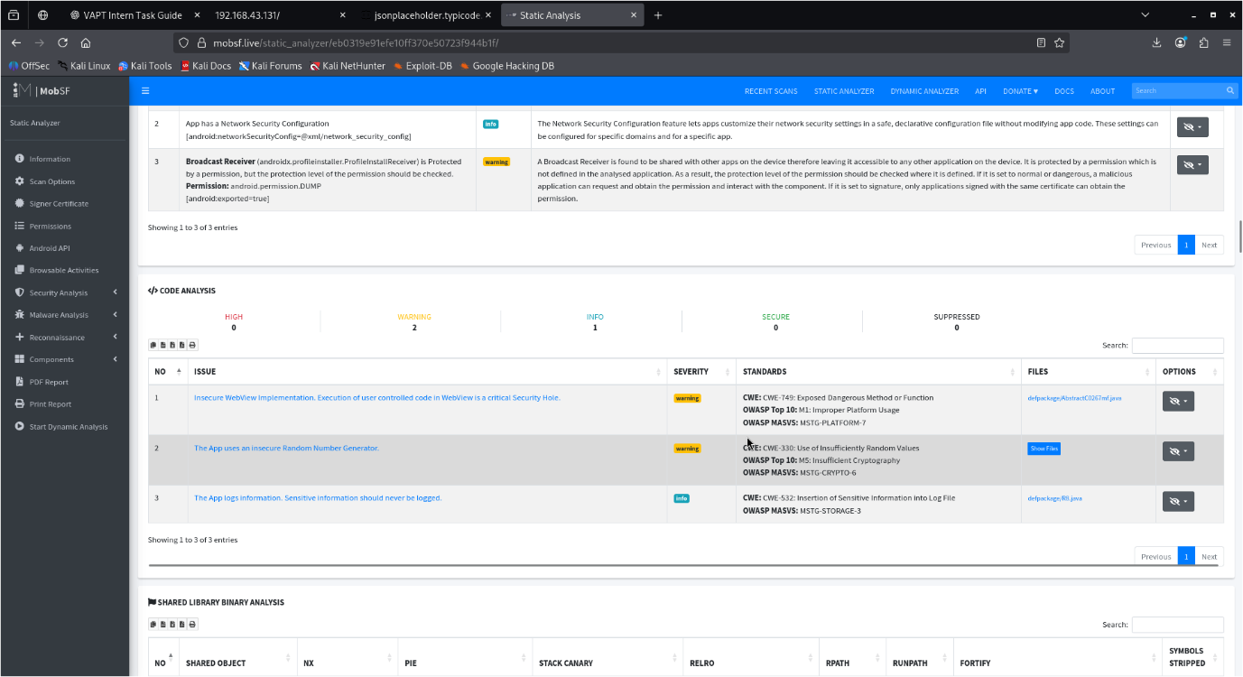

Test ID | Vulnerability | Severity | Target App
016 | Insecure Data Storage | High | test.apk

Dynamic Testing Summary (50 Words)
Dynamic testing was simulated using Frida to hook runtime functions and bypass authentication logic. This demonstrates how attackers manipulate app behavior. Secure storage, obfuscation, and runtime checks are critical for mobile security.

9. Capstone – Full VAPT Cycle
Timestamp | Target IP | Vulnerability | PTES Phase
2025-01-23 15:00 | 192.168.43.131 | VSFTPD RCE | Exploitation

10. Technical PTES Report (300 Words)
This full penetration testing simulation was conducted as part of the Week 4 advanced VAPT engagement using the Penetration Testing Execution Standard (PTES) methodology. The assessment was performed within a controlled and authorized lab environment using intentionally vulnerable systems to ensure ethical and safe testing practices.

During the reconnaissance and vulnerability analysis phases, exposed network services and outdated software components were identified on the target system. Automated scanning and manual validation revealed a critical vulnerability in the FTP service (VSFTPD 2.3.4) that could allow remote code execution. This vulnerability is a well-known backdoor flaw that can provide attackers with unauthorized shell access.

The exploitation phase demonstrated how attackers could leverage the VSFTPD misconfiguration to gain initial access to the target system. Although the exploitation was simulated for safety, the attack path accurately reflected real-world penetration testing scenarios where outdated services are commonly abused.

Post-exploitation concepts such as privilege escalation, lateral movement, and persistence were reviewed to understand how attackers maintain access and expand control within a compromised environment. Evidence handling and chain-of-custody principles were also documented to ensure the integrity and reliability of findings.

Finally, remediation strategies were proposed, including disabling vulnerable services, applying security patches, enforcing least-privilege access controls, and segmenting the network. A re-scan approach was recommended to validate remediation effectiveness. This capstone exercise reinforced the importance of structured testing methodologies, layered defenses, and clear communication in professional penetration testing engagements.

11. Non-Technical Summary (150 Words)
This security assessment identified serious weaknesses in a test system that could allow attackers to gain unauthorized access and potentially disrupt operations. A critical vulnerability was found in a network service that, if exploited, could provide attackers with full control over the affected system.
Although the testing was performed in a safe lab environment, the findings highlight the types of risks organizations face when outdated software and insecure configurations are present. Regular patching, secure configuration, and continuous monitoring are essential to prevent such threats.
By addressing these vulnerabilities and following best security practices, organizations can significantly reduce the likelihood of cyberattacks and protect sensitive data, systems, and business operations. This assessment demonstrates the importance of proactive security testing in maintaining a strong and resilient security posture.

12. Remediation Recommendations
- Patch vulnerable services
- Enforce least privilege
- Secure API authorization
- Implement network segmentation
- Apply mobile app security controls
- Conduct regular security testing

13. Key Learnings
- Advanced exploit chaining concepts
- API and network attack understanding
- Privilege escalation awareness
- Importance of layered defenses

14. Challenges Faced
- Tool limitations
- Simulation constraints
- Complexity of advanced exploits
- Time management

15. Conclusion
Week 4 demonstrated advanced cybersecurity techniques and professional reporting practices essential for real-world penetration testing.

